**Scene selection:**

I have chosen a scene from a still life picture on the internet.

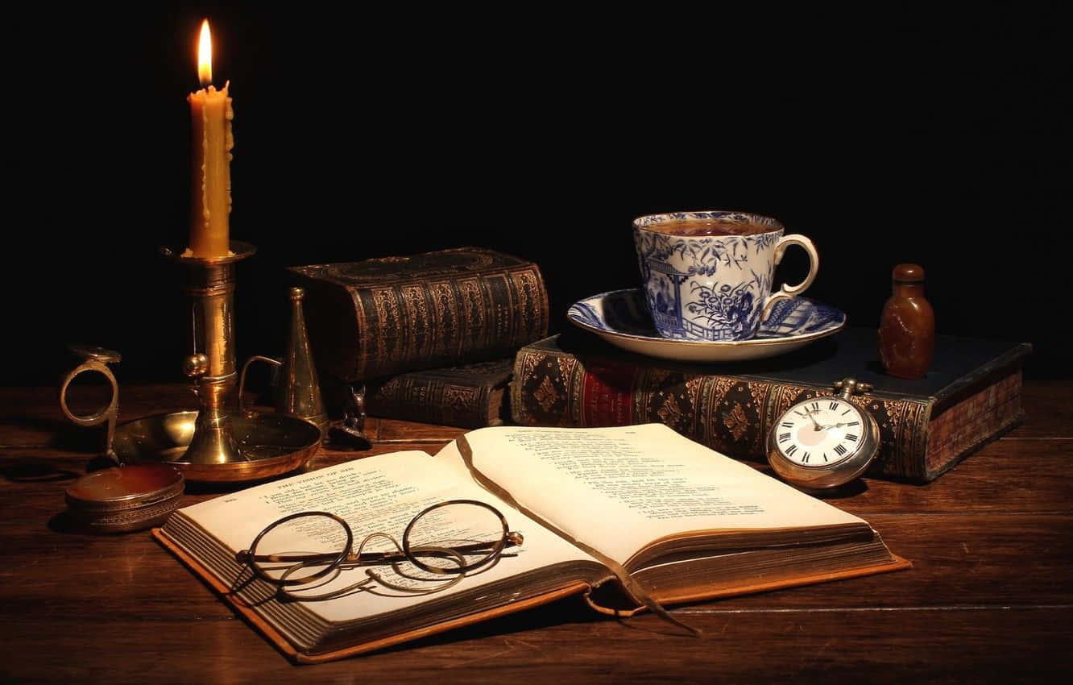

1. **Select a 2D image with objects to replicate in a 3D scene.**

I think the chosen 2D image is a great option because it shows a remarkable use of space by various objects. The composition is not boring but rather engaging, with no parallel lines or repetition of objects. In my opinion, it gives off a creative and artistic vibe, similar to a classic still life painting. The identification and placement of objects are clear, even in the low-light areas, such as the books in the background or the candle snuffer on the left. Although it is a single image from the internet, it is complete and sophisticated enough not to rely on other points of view.

1. **Discuss which objects will be replicated in 3D.**

There are 11 main objects in this scene. Three closed books are displayed in the background, varying in position, size, and rotation. Next, a small but noticeable silver pocket watch with smooth edges and a visible time dial is resting on one of the closed books on the right. A set of candle-related items (including a candle holder, snuffer, & candle) can be seen on the left side of the image. The candle is resting in the base of the holder, while the snuffer is placed beside it.

Above the rightmost book, there are two objects: a teacup with a handle and a saucer. The saucer is slightly deep, adding dimension to the arrangement. Next to the teacup is a small wooden container with rounded edges, shaped like a simplified human figure.

Finally, in the foreground, there is a thick, asymmetrical open hardcover book accompanied by a pair of round glasses resting on top of it.

What makes the image excellent is the interaction between all these objects. While they appear to be placed randomly, the scene’s perspective creates a sense of cohesiveness. No relative position is repeated, maintaining an organic sense of human usage that makes the composition believable, without falling into the stereotype of a boring, conventional desk setup.

1. **Explain which basic 3D shapes will be used to replicate the 2D objects.**

There are many ways to replicate the objects identified in the composition. Every object in the chosen scene can be approximated using multiple primitives. The closed hardcover books can be approximated using a rectangular box as the main block of pages, two thin rectangular boxes as the hardcover (which are slightly larger), and a flattened oval cylinder as the spine. All variations in size and thickness must follow the composition, though the use of primitives remains consistent.

The candle holder can be composed of a flattened cylinder as its base, a torus as the holder, and an elongated cylinder as the main body, where the candle (also a cylinder) will be placed. Spheres can be added to the candle to give the appearance of melted wax residue.

The snuffer can be assembled using a simple cone, a sphere at the tip of the cone, and a torus as the handle.

The pocket watch can be composed of a flattened cylinder with a slightly larger torus around it to give the edges a rounder appearance. Additionally, two smaller cylinders (one flattened and the other elongated) can be used to approximate the timer dial.

The teacup can be approximated with a tapered cylinder, with the smaller circle as its base. Additionally, an oval torus, slightly rotated, can be used as the handle. The saucer (tea plate) can be approximated as a flattened, tapered cylinder with the smaller circle as its base.

The wooden liquid container can be assembled using an enlarged sphere (stretched along its height), with its lower base passing through the book to give the appearance of a flat bottom. A smaller cylinder should be used as the neck of the container, while a sphere (also intersecting the cylinder) can be used as the cap, giving the appearance of a halved sphere.

Finally, the glasses can be simply composed of two equally sized, thin tori and two very elongated cylinders as the ear holders. The open book can be assembled using a similar process as the closed books.